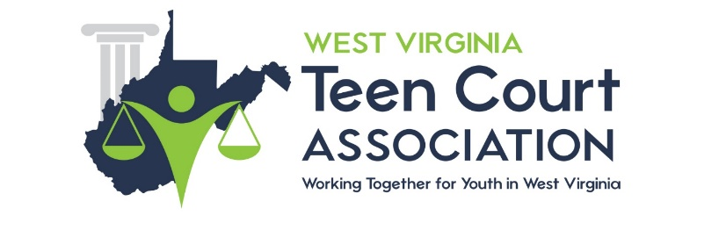

Letter of Working Agreement

This letter confirms the working agreement between Community Connections, Inc. (representing the West Virginia Teen Court Association (hereafter called WVTCA) and "XXXX”.

Teen Court Overview:
The WVTCA was created to increase the capacity of our current juvenile justice system throughout West Virginia by allowing youth to participate in a positive peer pressure prevention system (teen court), and serve as an early intervention tool to hold first time misdemeanor and status offenders accountable for their actions in an efficient and effective manner. Teen court programs are shown to be an effective tool in preventing youth risk behaviors, and also an effective tool in keeping substance related issues to a minimum. This meaningful forum also allows participants the ability to learn and practice new skills with a “hands-on” approach and will create new avenues for building ties between youth and the community.

Project Description:
The purpose of this project is to research and analyze various strategies for the potential development of a Teen Court Program in XXXXX County. Part of this developmental process will include, but it not limited to the following...
- Collection of Key “Letters of Working Agreement” between Circuit Judges and County Probation Officer(s) - MANDATORY
- Two page statistical overview of the need for a Teen Court program in XXXX County. In addition, documentation should show adequate level of participation by local community leaders (judges, probation officers, youth, etc.), attendance rates, diversity of membership, and satisfaction with the Teen Court process.
- Formation of an Advisory Group consisting of key stakeholders. At least one member will represent youth, parents, the legal system, community-based organizations, religious affiliations, public heath, social services, youth-serving organizations, substance abuse treatment services, education, the media, and the business sector.
- To advocate for the $5.00 fee for Teen Court operations through the local County Commission. XXXX County understands that per §49-5-13d of the WV State Code they are authorized and will work to adopt a mandatory fee of up to $5.00. Any mandatory fee established by a county commission or city council in accordance with the provisions of this subsection shall be paid by the defendant on a judgment of guilty or a plea of nolo contendere for each violation committed in the county or municipality of any felony, misdemeanor or any local ordinance, including traffic violations and moving violations but excluding municipal parking ordinances.
- Identification of other key possible funding sources
- Monthly reports (due last day of every month)
Timelines:
The project will last from DATE through DATE.
- Letter of Agreement DATE
- Letters of Working Agreement with Judges/Probation DATE
- Formation of Stakeholder Advisory Group DATE
- Collection of fees DATE
- Monthly reports
- Final report DATE

Responsibilities of Each Party:
WVTCA agrees to provide bi-monthly conference calls and a two day free training to XXXX. Additional support will be provided through independent emails, phone conversations and, if needed, personal contact. XXXX agrees to provide the information listed above. Upon signing this letter of working agreement (blue ink) and returning it to Community Connections, the WVTCA agrees to pay a one-time stipend in the amount of $1000 for the potential development of a Teen Court Program in XXXX County. A letter of working agreement for Judges and Probation Officers MUST BE SIGNED prior to receiving a stipend. Other items listed within the Program Description are part of the working agreement with the WVTCA and all attempts must be made to achieve them.

An invoice in the amount of $1000 should be sent to Community Connections, Inc. no later than DATE.

___________________________ ___________________________
Greg Puckett XXXX
Community Connections XXXX
West Virginia Teen Court Association

